Macroinvertebrate Image Analysis System in Python
Members:
Jamyang Rigsel, Ansh Sharma, Gabriel Ko
Project Goal: To build a system using Python for analysing images of freshwater macroinvertebrates. We implemented Stage 1 and Stage 3 of the assessment. The data analysis and the application deployment. Therefore we focused on indexing the dataset to output useful EDA visuals and then made a Tkinter app to present that information via a simple UI.
System Design Summary
The system divides the code into separate modules and classes. Each having their own responsibility, making the project easier to understand, debug and maintain.
Initially the dataset was stored in Google drive due to its large size, but after advice from the Professor, we downsized the dataset to 5 folders and moved them to Github. Stage 1 EDA was coded and completed in Google Colab and the outputs were saved into the repository.
The stage 3 Tkinter App then used the outputs and presented them through a simple UI. Allowing users to choose what information they wanted to view.
Class and Module Overview
records.py:
This file contains the ImageRecord dataclass, which shows the metadata for an image.
dataset_indexer.py:
It’s role is to scan the dataset and build a dataframe with Pandas. It searches through the raw data, finds the images that are supported and reads each image using OpenCV to extract information such as the image dimensions and channels.
eda_service.py:
This generates the main analysis outputs. This class helps keep the EDA logic separate from the indexing logic.
plotting.py:
Plotting functions that were used to make visual outputs such as the random image sample grids.
main.py:
This file has the full Stage 1 EDA. It creates the directory for the output, indexes the dataset, runs the EDA and saves the outputs into the correct folder.
app.py:
This file contains the Python code for the Tkinter UI app. Makes the output easy to access.
Python Packages Used
Pathlib, OpenCV, Pandas, Matplotlib, Seaborn, Tkinter, Pillow.
Key Features Implemented
Indexing image data and extracting image metadata.
Generating class, image size and image channel distribution charts.
Generating sample image grids.
Saving all the outputs into the repository.
Displaying the EDA outputs with a simple Tkinter UI.
Clear class responsibilities and implemented object-oriented coding.
Examples of Outputs
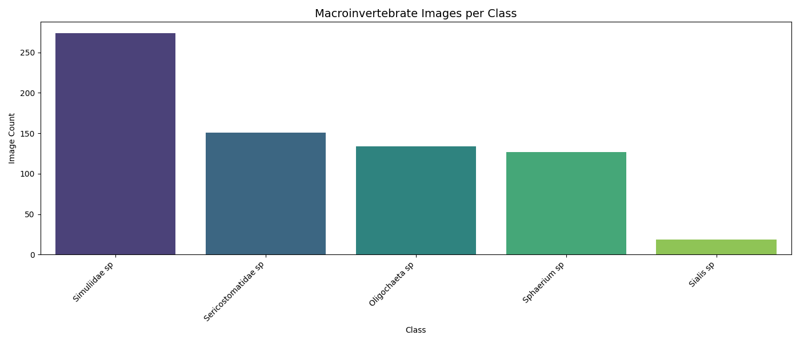
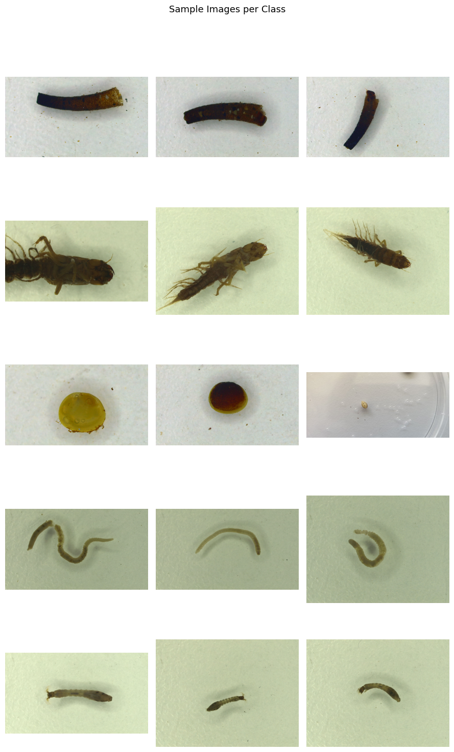

Testing summary
Scenario | Expected Result | Status
Run Stage 1 EDA pipeline | EDA outputs are saved to outputs/eda | Passed
Check class distribution output | class_distribution.png is created | Passed
Check image size output | image_size_distribution.png is created | Passed
Check class imbalance output | class_imbalance.png is created | Passed
Check channel distribution output | channel_distribution.png is created | Passed
Check sample grid output | sample_grid.png is created | Passed
Open Stage 3 app | App/menu opens successfully | Passed
Select an EDA output in the app | Correct output is displayed/opened | Passed
Missing file handling | App shows an error message instead of crashing | Passed
Acknowledgement of Reused or Adapted Code
A lot of the code structures in Stage 1 were adapted from the Assignment 3 guidance document and weekly unit materials. The code was modified and made to fit into the project structure.
Work Division Summary
Gabriel Ko: Stage 1 EDA development in Google Colab. Output generation and testing.
Ansh Sharma: Repository planning and dataset pushing. Project structure and documentation.
Jamyang Rigsel: Stage 3 deployment and integration with EDA outputs. Repository creation.
Limitations and Future Improvements
Stage 2 was not attempted. A future improvement would be to add Stage 2 predictive analytics to the project. Our main limitation was not being able to use the Tkinter UI without first downloading the repository into your local files. It would also be beneficial to be able to run the UI online and not have to push the repository locally.

Conclusion
This project accomplished it’s goal of demonstrating a working Python app that analyses macroinvertebrate images. We ticked the boxes of using object-oriented design and a variety of python packages. The project of a small scope, but it is complete and very well integrated. It was also documented and classified well, making it readable and easily testable.

